This database aims to remind patients to take their diabetic drugs on time, to keep track of the pharmacy and its location so that prescriptions can be purchased on time, to monitor RBS readings at regular intervals, to keep doctor information such as the doctor's name and contact information, and to help them improve their lifestyle so that they can meet their target blood sugar level. It assists in the prompt provision of all current details for care in the event of an emergency.

Objectives:

* Patient information
* Record RBS readings in regular interval
* Provide medication reminder to a diabetic patient
* Doctor’s information and Doctors’ appointments
* Update medications according to revisits
* Pharmacy and Drug information
* Refills at pharmacy
* Information regarding special alerts on medication
* Provide information regarding lifestyle changes
* Track the patient’s progress

**Entities and Attributes:**

1.Cardholder: Cardholder - ID (Primary Key)

* Cardholder name
* Cardholder age
* Contact number
* Emergency contact details
* Hospital - ID (Foreign Key)

2.Doctor: Doctor ID (Primary Key)

* Doctor name
* Doctor address
* Doctor Contact number
* Hospital ID (Foreign Key)

3.Hospital: Hospital ID (Primary Key)

* Dept. of Endocrinology
* Dept. of Medicine
* Dept. of Radiology
* Dept. of Pathology

4.RBS Record (Record of Blood Sugar Levels): RBS Record ID (Primary Key)

* Date
* Time
* Normal Range
* Cardholder - ID (Foreign Key)

5.Diabetic Medicines: Diabetic Medicines ID (Primary Key)

* Drug name
* Dosage
* Side effects
* Drug regimen
* Instructions
* Cardholder - ID (Foreign Key)

6.Pharmacy: Pharmacy ID (Primary Key)

* Pharmacy name
* Pharmacy contact number
* Cardholder – ID (Foreign Key)

7.Medical History: Medical History ID (Primary Key)

* Cardiovascular diseases
* Neural diseases
* Renal diseases
* Allergies
* Cardholder ID (Foreign Key)

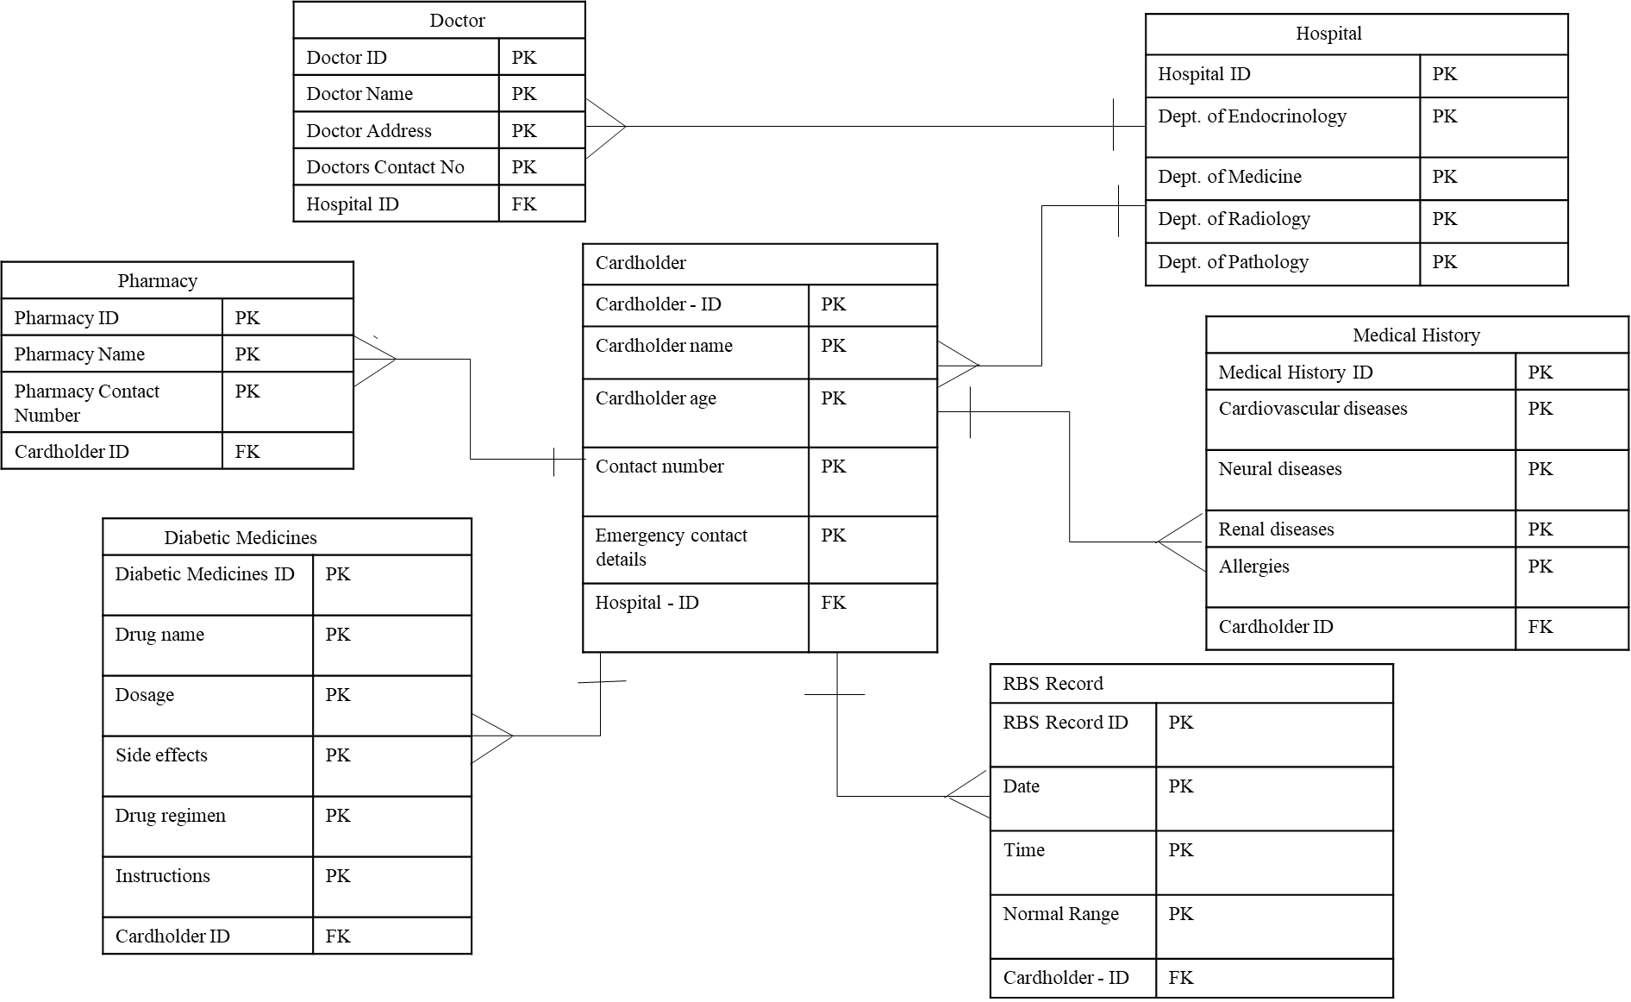**ER Diagram**